
REQUEST FOR PROPOSAL

RFP No. 2620003

Salesforce Implementation Partner

For

KERRY`S PLACE AUTISM SERVICES

Issue Date: May 25, 2026

Closing Time: 2:00 p.m. Eastern Time on

June 22, 2026
REQUEST FOR PROPOSAL (“RFP”)

RFP #2620003 – Salesforce Implementation Partner

Receipt Confirmation Form

To: Procurement Department
Kerry`s Place Autism Services
Email: procurement@kerrysplace.org

Re: RFP #2620003 – Salesforce Implementation Partner

Vendors are requested to acknowledge receipt of the RFP for a Salesforce Implementation Partner for Kerry`s Place Autism Services and their intent to respond by sending this form by email to the attention of Jennifer Oram at procurement@kerrysplace.org. Vendors submitting this response will be notified of any addendums issued to this RFP, according to the name submitted on this document.

I hereby acknowledge receipt of the above noted RFP.

Please check your answer
I/We | DO |  | DO NOT |  | Intend to submit a Proposal to this RFP

(Company Name |  | (Representative’s Signature)
(Address) |  | (Name—Please Print)
(City) |  | (Title)
(Phone) |  | (Date)
(Email)

- INTRODUCTION

Kerry’s Place (www.kerrysplace.org) is Canada’s largest Autism services provider serving the lifespan of Autistic individuals and their families. Over our 50 years, we’ve built locations and partnerships across southeastern Ontario to help Autistic people of any age or ability build skills, gain independence, make friendships, and achieve their goals. We do this by delivering individualized, evidence-based Autism supports and services, group programming, community involvement opportunities, camps and our Supported Living and Supported Independent Living services. In addition to operating 88 homes for Autistic adults, we run a wide range of community programs serving over 7,000 Autistic children, youth and adults, and their families.

Type of Agreement

The selected Vendor will be expected to enter into an agreement as contemplated by the RFP and project details.

Project Details

- Project Overview and Objectives
The implementation of Salesforce CRM will enhance customer experience by allowing autonomous service management within the Kerry’s Place website, while improving backend efficiency for staff. In addition, Salesforce will provide user data and enable data-driven marketing strategies leading to higher conversation rates.
Kerry’s Place completed work with Deloitte from Nov. 2025-Jan. 2026 which included a needs assessment as well as a system evaluation and vendor recommendation. Refer to Schedule G – Section 1 – Current State for additional information.
With the selection of Salesforce as our CRM system of choice, we are now seeking a partner to help us navigate all aspects of implementation, configuration and support (outlined in Phases 3,4 and 5 in scope of work) into our organization.
Budget up to $200K for this project. Proponent must outline any portion of the scope that isn’t included within their proposal.
Objectives of Implementation:
- Configure Salesforce system to match existing processes/needs according to functional requirements (Schedule G – Section 2 Functional Requirements)
- Integrate Salesforce with existing systems, including research, acquisition/ implementation of third-party tools (with Kerry’s Place approval once research is presented) where required to deliver value quickly while minimizing disruption (further details included below)
- Lead data migration and integration
- Provide user training and enablement
- Assist with go-live and early adoption as well as managed services post go-live
- Successful proponent for this engagement will improve data flow, reduce manual handoffs, enhance client experience, and enable reliable reporting across the full-service lifecycle.

- Requirements of Implementation Partner
- Insurance requirement of 2-5 million (commercial and general liability insurance)
- Must be a Canadian company or have at least 90% of the required staff to deliver the contracted services located in Canada
- Community, Social, Developmental Services, Health Care and/or non-profit experience
- Experience working with Autism providers considered a benefit
- Technical Expertise:
  - Proficient in Microsoft infrastructure (e.g., MS Server, Windows 10/11, MS SQL)
  - Knowledge of compliance and security best practices (see Appendix C)
  - Awareness of customization, configuration, and automation options
  - Experience with API and third-party tool integration
  - Skilled in data migration
- Experience implementing Salesforce platforms:
  - Nonprofit Cloud – Enterprise Edition
  - Salesforce Scheduler - Enterprise Edition
  - Customer Community Plus for Nonprofits
  - Premier Success Plan – Salesforce Platform
  - Marketing Cloud – Advanced – Enterprise Edition
  - Customer Data Cloud for Marketing

- Mandatory Requirements of Implementation Partner
Mandatory Criteria | YES/NO | Page # of your response that proves Mandatory Criteria
Minimum 5 years’ proven experience implementing Salesforce software
Experience working with Community, Social, Developmental Services, Healthcare and/or Non-Profit organizations
Not a U.S. business as defined in Ontario’s Procurement Restriction Policy (See Schedule A) or commits to have at lease 90% of the required staff to deliver the contracted services located in Canada

- Scope of Work – Implementation and Configuration

Phase 1: Discovery & Needs Assessment – COMPLETE
Phase 2: System Evaluation & Selection – COMPLETE

Phase 3: Implementation Planning
- Proponents are expected to review schedule G carefully and clearly describe how they will integrate with, replace, or interface with the identified processes and systems.
  - Proponents will investigate and document configuration for the following
    - Processes initiating client engagement:
    - Website exploration
    - Client inquiries (web, phone, email)
    - Marketing channel interactions
  - Processes related to onboarding and eligibility determination:
    - Intake forms
    - Decision and processing workflows
    - Client service account creation
    - Service agreements
    - Client information meetings
    - Discovery calls (professional scheduling and delivery)
  - Ongoing administrative and service coordination processes:
    - Client profile creation and management
    - Personal and health form updates
    - Client and internal communications
    - Support inquiries
    - Finance account creation and management
  - Preparation activities prior to service delivery:
    - Client registration
    - Scheduling and appointment logging
    - Program communications
    - Payment collection
    - Invoicing
    - Distribution of invitations and materials (professionals)
  - Execution and quality tracking:
    - Session delivery
    - Feedback surveys
    - Reporting
  - End of service and re-engagement processes:
    - Re-purchase of services
    - Enrollment in additional services
    - Client offboarding
- Develop a detailed implementation plan with milestones
  - Proponents must include, at minimum, the following:
    - A system-to-system integration diagram covering all lifecycle stages
    - Identification of:
      - Systems of record
      - Source and target systems
      - Description of integration methods (e.g., API, middleware, manual interface)
      - Identification of manual vs automated processes
      - Assumptions, constraints, and dependencies
      - Integration risks and mitigation strategies
      - A phased implementation roadmap aligned to the FFS journey
- Coordinate with vendor, and internal IT and operational teams
- Coordinate with all integration vendors when changes are required
- Design system architecture and integration points
- Prepare data migration strategy and backup protocols
  - Data security, privacy, and auditability are mandatory considerations

Phase 4: Implementation, Integration, Configuration & Training
- Perform implementation of the following Salesforce modules:
  - Nonprofit Cloud – Enterprise Edition
  - Salesforce Scheduler - Enterprise Edition
  - Customer Community Plus for Nonprofits
  - Premier Success Plan – Salesforce Platform
  - Marketing Cloud – Advanced – Enterprise Edition
  - Customer Data Cloud for Marketing
- Proponent must address integration across the following functionality:
  - Client Relationship Management through Salesforce
  - Intake and Case Management
  - Scheduling and Appointment Management
  - Communications and Notifications
  - Document and Form Management
  - Financial Management (billing, invoicing, payments)
  - Marketing attribution and inquiry tracking
  - Survey and feedback collection
  - Reporting and analytics
  - Service lifecycle management
- The following systems and platforms are currently in use or referenced and must be part of the integration.
  - Technology systems
    - Organizational Website (kerrysplace.org)
    - MyCommunityHub
    - EMHware
    - Microsoft 365 Office
    - Microsoft 365 Outlook Calendars
    - Freshbooks Invoice and Stripe payment
    - MyCommunityHub (would like to have part of integration)
  - Communications & Engagement Tools
    - Phone
    - Email
    - Facebook
    - Meta Business tools
    - Other social media platforms
    - Constant Contact
    - Microsoft Teams
    - Zoom videoconferencing
    - In person interactions
  - Analytics & Tracking
    - Google Analytics
    - Tableau
  - Scheduling & Interaction Channels
    - Online and professional scheduling tools
    - Appointment logging systems
    - Video conferencing platforms
- Migrate existing customer data securely
- Develop and deliver user training sessions and supporting documentation
- Support change management and user adoption strategies
- Monitor adoption and address user feedback
- Lead testing and quality assurance, Kerry’s Place sign-off required

Phase 5: Post-Implementation Support
- Evaluate system performance and user satisfaction
- Recommend enhancements or further customizations
- Provide support for troubleshooting and optimization
- Salesforce systems and integration support to be provided by proponent for 1 year

Out of Scope:
- Development of a new website from scratch (unless specified later)
- Custom mobile app development (unless added to scope)
- Replacement of other systems such as EMHware, Sage, ADP, Raiser’s Edge, etc.

- Timeline & Milestones
Task | Start Date | End Date | Milestones
Phase 1: Discovery & Needs Assessment
Discovery, Needs Assessment, System Evaluation and Recommendation | Nov. 2025 | Jan. 2026 | COMPLETED
Phase 2: System Evaluation & Selection
Vendor Review & Selection | Dec. 2025 | Mar. 2026 | COMPLETED
Phase 3: Implementation Planning
Develop a detailed implementation plan with milestones | Jun. 2026 | Aug. 2026 | Coordinate with vendor and internal IT and operational teams
Develop a detailed implementation plan with milestones | Jun. 2026 | Aug. 2026 | Prepare data migration strategy and backup protocols
Design & Customization | Jun. 2026 | Aug. 2026 | Wireframes, UX/UI finalized, platform customized
Integration & Development | Jun. 2026 | Aug. 2026 | Integrate CRM with website, test backend functions
Internal Testing (UAT) | Jun. 2026 | Aug. 2026 | User acceptance testing by staff and stakeholders
Phase 4: Deployment & Training
System installation and configuration | Aug. 2026 | Oct. 2026 | Migrate existing customer data securely
Develop and deliver user training sessions and supporting documentation | Aug. 2026 | Oct. 2026 | Support change management and user adoption strategies
Testing and quality assurance | Aug. 2026 | Oct. 2026 | Monitor adoption and address user feedback
Rollout Phase I (Soft Launch) | Oct. 2026 | Dec. 2026 | Pilot with a select group of users; prepare for full roll out (below)
Full Rollout (All Users) | Jan. 2027 | Mar. 2027 | System available to all customers and staff across identified programs
Phase 5: Post-implementation Support
Post-launch Support | Apr. 2027 | Jun. 2027 | Maintenance, performance monitoring, required edits/updates

Note: dates subject to change based on project rollout and findings and consultation with implementation support partner

- INSTRUCTIONS TO BIDDERS

Communications during RFP Period

All questions and communications regarding this RFP should be directed to the Bid Administrator.

Jennifer Oram (Bid Administrator)
Procurement Officer
Kerry`s Place Autism Services
17345 Leslie Street, Suite 200
Newmarket, ON L3Y 0A4
Telephone: (905) 841-6611 ext. 90305
Facsimile: (905) 841-6651
E-mail address: procurement@kerrysplace.org

Closing Date for Submissions of Proposal

To be eligible for consideration in this RFP process, the Vendor’s Proposal must be received by 2:00:00 p.m. Eastern Time on June 22, 2026 (the “Closing Time”) via one of the 2 below options:

Received via email bearing vendor’s name and “RFP#2620003 – Salesforce Implementation Partner” in the subject line at:
procurement@kerrysplace.org

Or

Physical bid should be in a sealed package bearing the Vendor’s name, return address, and “RFP # 2620003 – Salesforce Implementation Partner” at:

Kerry`s Place Autism Services
17345 Leslie Street, Suite 200
Newmarket, ON L3Y 0A4
Attention: Jennifer Oram, Procurement Officer

Proposal received after the Closing Time

Proposals received after the Closing Time shall not be considered and shall be returned to the Vendor unopened. Each Vendor is responsible for the actual delivery of its Proposal to the address and location listed above, regardless of whether the Proposal has been given to couriers, delivery services, and Canada Post for delivery to that location.

Format

The Proposal should be comprised of and formatted as follows:

- Electronic File titled “Proposal – Excluding Pricing Schedule – includes all items within the Technical Proposal Section
- Electronic File titles “Pricing Schedule” – includes Schedule F
Or
- One (1) original paper copy, in a sealed envelope excluding Pricing Schedule, and clearly identified as “Proposal - Excluding Pricing Schedule”
- One (1) original paper copy of the Pricing Schedule, in a sealed envelope clearly identified as “Pricing Schedule” including all required forms & documentation
- One (1) electronic copy, in read only format (on a USB stick in Microsoft Office format) of the “Pricing Schedule” including all required forms & documentation

Right to Cancel the RFP

Kerry’s Place shall have the right to cancel this RFP, at any time, either prior to or after Closing Time without award. Thereafter, Kerry’s Place may issue a new tender, RFP, RFQ, sole source or do nothing. Kerry’s Place shall not be obligated to provide reasons for the cancellation.

Proposal Structure

The individual sections are to be segregated. The Technical Proposal will be evaluated first. If it is found in order, the Price Proposal will be reviewed. The Technical Proposal shall have no direct or indirect reference to any price or financials related to the proposal. Any submissions that are found violating this clause at any stage may be disqualified without further explanation.

Technical Proposal Requirements
Vendor is to include the proposed approach to the project and intended scope of work, walking through each section listed within the project. Proposal MUST also include the following:
- Completed Mandatory Criteria Chart & Reference page number within your response.
- Proof of Credentials as relates to the Services above
- Team size and capabilities, including resumes of implementation team
- Provide details on your approach to all sections within the project
- Provide details of your timeline
- U.S. Business Declaration Form - Schedule A
- Corporate Overview – Schedule B
- Agents / Subcontractors Form – Schedule C
- Declaration of Conflict Statement – Schedule D
- Vendor References – Schedule E
- Proof of Liability Insurance

The Vendor shall provide proof and maintain insurance and pay such assessments as will protect him/her, including Subcontractors and Kerry’s Place from any claims under WSIB and from other claims for damage which may arise from operations under this Agreement including:
- Comprehensive public liability and property damage insurance providing coverage up to $5,000,000.00 (Five Million Dollars) inclusive against liability for bodily injury or death on a per occurrence basis or damage to property. Such insurance shall include Kerry’s Place as additional insured. Vendors that do not currently comply with the above insurance coverage should include in their quote a cost to provide the coverage requested.

The Vendor is required to provide a “WSIB Certificate of Clearance”, or in cases of an independent operator, a “WSIB Letter of Proof” confirming their status as such. In cases of the Vendor being an independent operator and written proof of such has been received by Kerry’s Place, the Vendor will be required to sign a “Liability Waiver”.

IT SHALL BE THE SOLE RESPONSIBILITY OF THE VENDOR TO DETERMINE WHAT ADDITIONAL INSURANCE COVERAGE, IF ANY, IS NECESSARY AND ADVISABLE FOR ITS OWN PROTECTION AND/OR TO FULFIL ITS OBLIGATIONS UNDER THIS AGREEMENT. ANY ADDITIONAL INSURANCE SHALL BE PROVIDED AND MAINTAINED BY THE VENDOR AT ITS OWN EXPENSE.

Pricing Proposal Requirements
Completed Schedule F – Price Form
- EVALUATION PROCESS

The objective of the evaluation process is to identify the Proposal(s) that most effectively meet the requirements of this RFP leading to the determination of the Proposal that provides the best overall value for Kerry’s Place.

The steps in the RFP evaluation process are as follows:

- Evaluation of Technical Requirements
- Evaluation of Pricing

Weighted Evaluation Criteria

Evaluation Criteria | Weighting
Business/Corporate Profile | 10
Ontario Business – Canadian Business | 10
Technical Proposal | 30
Vendor References (Schedule E) | 5
Cost Proposal (Schedule F) | 30
Presentation | 15
Total: | 100%

The Evaluation Criteria listing also represents the order in which criteria will be considered, we will be short-listing to 2 vendors prior to the Presentations. Requirements for the presentation to be shared with short-listed vendors priors.

Financial Evaluation

The financial proposal is evaluated based on its response to the Price Schedule F. The maximum number of points for price is 30. The maximum number of points will be allocated to the lowest price. All other proposals will receive points in inverse proportion according to the following formula:

Price offer points for a [Max number of points for the Price Offer] x [Lowest price]
Proposal being evaluated = [Price offer being evaluated]

SELECTION MILESTONES

Event | Date
RFP issued to Vendors | May 25, 2026
Vendor questions to be received in writing | June 12, 2026
Submission of Proposals/Closing Time | June 22, 2026
Election to proceed and selection of Vendor(s) | June 29, 2026
Anticipated agreement start date | July 6, 2026
Notification to unsuccessful Vendor or Vendor(s) | July 6, 2026

The above dates are subject to change at the sole discretion of Kerry’s Place. All times are shown as Eastern Time. In the event a change is made to these dates, the Vendors that have completed the Receipt of Confirmation Form will be informed by addenda.

SCHEDULE A: U.S. BUSINESS DECLARATION FORM

In response to the government of Ontario’s Procurement Restriction Policy we are asking all our active suppliers to provide a declaration on whether they are a United States (U.S.) business.

A U.S. business means a supplier, manufacturer or distributor of any business structure (includes a sole proprietorship, partnership, corporation or other business structure) that:

- has its headquarters or main office located in the U.S.*, and
- has fewer than 250 full-time employees in Canada.

*if your business is a subsidiary of another corporation, part 1 of the definition above is met if that corporation has its headquarters or main office located in the U.S.

We require this completed form prior to continuing business.

Vendor Name:
Are you a U.S. business, according to definition above? |  |  | YES NO
Name of Signing Officer:
Signature of Signing Officer:
Position Title:

SCHEDULE B: ORGANIZATION OVERVIEW

THIS SECTION SHould BE COMPLETED BY ALL VENDORS
Vendor Name: ___________________________________________________
Service Capability
This section requests specific information from Vendors about their operations as it relates to their ability to provide service. Please list any assumptions you make when responding to questions.

Item | Vendor Response
Legal Name
Head Office Address
Office Address within Ontario
Certifications
Areas of expertise
Number of years in business
Current number of support personnel
Where are your current support personnel located?
Is your company or division currently going through acquisition, bankruptcy or restructuring?
Provide an overview of your organization & the services you provide.
Provide details of any project that you have completed similar to the scopes provided within this RFP. Provide multiple examples if applicable.

SCHEDULE C: AGENTS/ SUBCONTRACTORS FORM

THIS SECTION MUST BE COMPLETED BY ALL VENDORS

The Vendors shall indicate whether the Vendor intends to use agents or subcontractors to perform the services outlined in the Agreement and shall provide details on who they are and the service(s) the agent/subcontractor shall perform. The Contractor shall preserve and protect the rights of the parties under the Contract with respect to work to be performed under subcontract, and shall: .1 enter into contracts or written agreements with Subcontractors and Suppliers to require them to perform their work as provided in the Contract Documents; .2 incorporate the terms and conditions of the Contract Documents into all contracts or written agreements with Subcontractors and Suppliers; and .3 be as fully responsible to the Owner for acts and omissions of Subcontractors, Suppliers and of persons directly or indirectly employed by them as for acts and omissions of persons directly employed by the Contractor.
If the Vendor is not using agents or subcontractors on this RFP, the Vendor should initial beside “not applicable”.

Agent/ Subcontractor #1 | Vendor Response
Company Name
Address
Service to be performed:

Agent/ Subcontractor #2 | Vendor Response
Company Name
Address
Service to be performed:

Not Applicable ________________

Vendor Name
Authorized Signature
Name (please print):
Position:
Date:

SCHEDULE D: DECLARATION OF CONFLICT STATEMENT

Please identify any person(s) employed by Kerry’s Place or a member of Kerry’s Place staff that:

- Has direct or indirect financial interest in the award of an Agreement resulting from this RFP;
- Is currently employed by, or is a consultant to, or under Agreement to the Vendor;
- Is negotiating or has an arrangement concerning future employment or contracting with the Vendor, or;
- Has an ownership interest in, or is an officer or director of the Vendor

RE: RFP #2620003 – Salesforce Implementation Partner

Names: ___________________________________________________________________________.

Please check your answer
I/We declare | A conflict of Interest |  |  | NO conflict of interest
(Company Name |  |  |  |  | (Name – Please Print)
(Phone) |  |  |  |  | (Representative’s Signature)
(Email) |  |  |  |  | (Title)
 |  |  |  |  | (Date)

SCHEDULE E: VENDOR REFERENCES FORM
Vendor Name: ___________________________________________________
Vendors are requested to provide a minimum of three (3) references where your organization implemented Salesforce in a similar environment. Reference sites should be similar in focus, size and complexity to the Kerry’s Place proposed environment and preferably in Ontario.
Please fill out the table as completely as possible.

Reference 1 | Vendor Response
Name
Address
Number of years’ service provided
Contact Information
(Name/title/Phone/E-mail):

Reference 2 | Vendor Response
Name
Address
Number of years’ service provided
Contact Information
(Name/title/Phone/E-mail):

Reference 3 | Vendor Response
Name
Address
Number of years’ service provided
Contact Information
(Name/title/Phone/E-mail):

SCHEDULE F: PRICE FORM

All prices are to be quoted in Canadian dollars, and HST is to be shown separately. Please state all costs clearly and completely; Kerry’s Place will not accept nor pay any hidden costs or costs not disclosed in response to this RFP.
Form can be exported to excel for response.

- Price

Description | One-Time Expenses | Re-occurring Expenses | HST | Total CAD for 1 year
Licensing Fees 3rd party tools – Software Licenses
Licensing Fee 3rd party tools – User Licenses
Implementation Costs
-Setup and Installation
-Data Migration
-Customization
-Integration
Consulting Fees
-Consulting Fees
-Project Management
Training Costs
-User Training
-Administrator Training
Support and Maintenance – 1 year
-Technical Support
-Maintenance Fees
Additional Services
-Testing
-Documentation

 | Description | Services Fee Amount | HST | Total CAD
Detail Listing of any other expenses or fees

Payments will be issued as follows:

Deposit – 25%
Phase 3 Completion – 25%
Phase 4 Completion – 25%
Phase 5 Completion – 25%

Signature of bidder ______________________________________________

Name and title _________________________________________________

SCHEDULE G: ADDITIONAL INFORMATION

Section 1 - Current State

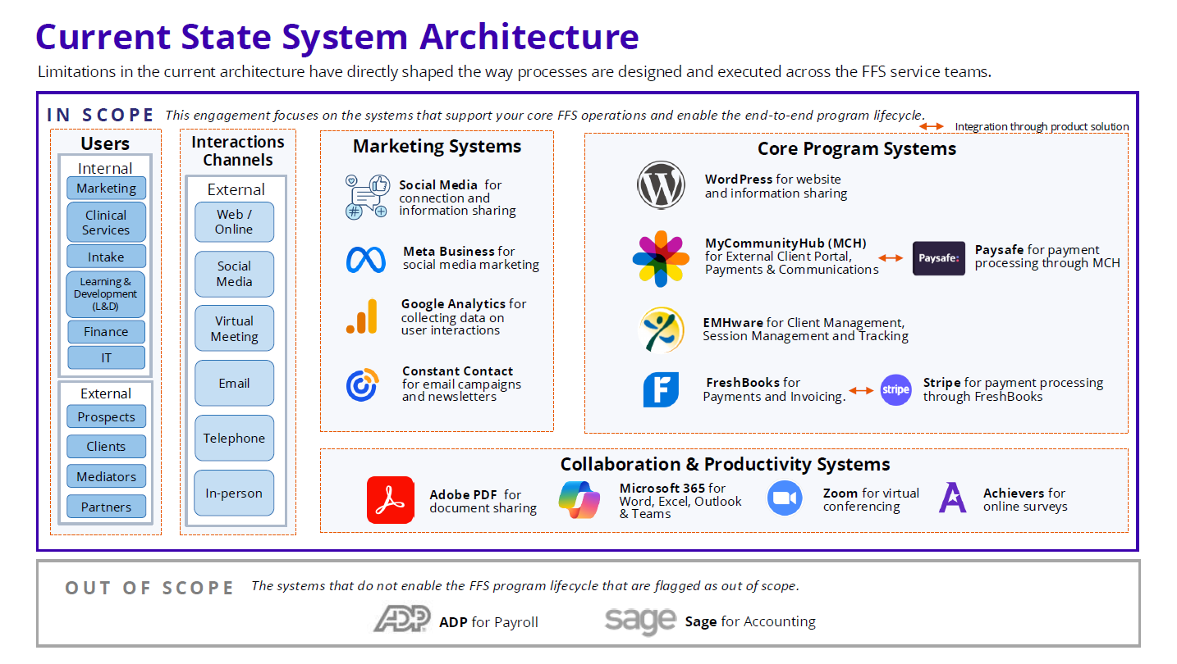

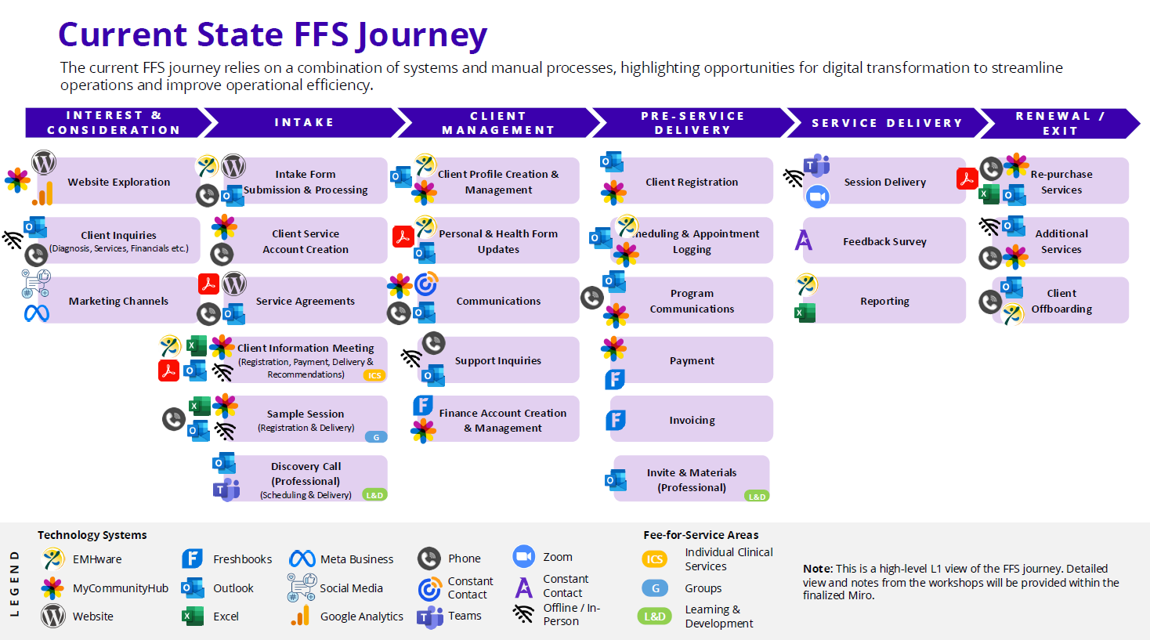

*FFS – Fee for Service

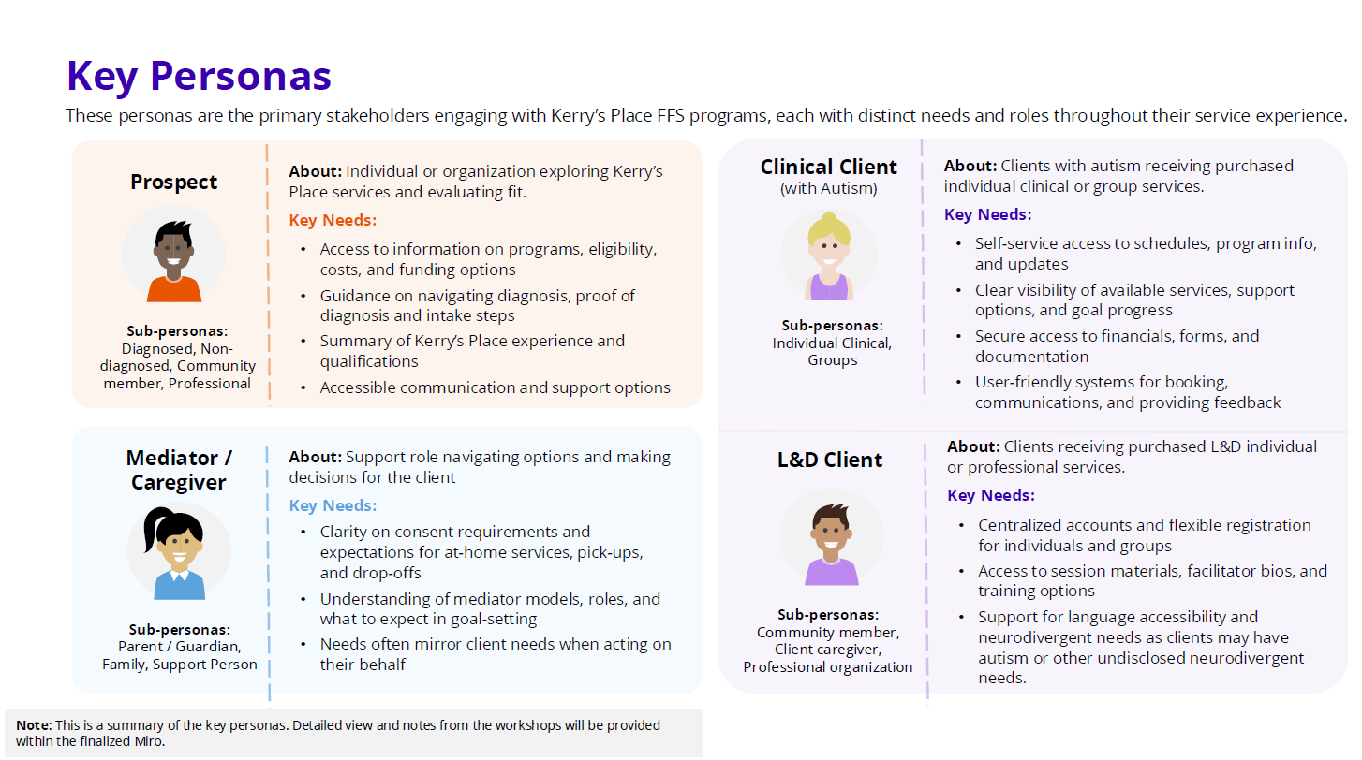

Section 2 – Kerry’s Place Functional Requirements

Section 3 - Minimal Viable Product (MVP)

- The MVP (Minimal Viable Product) establishes a baseline set of capabilities to deliver value to users within the purchased services end-to-end business process flow
- Provides direction for short-term prioritization and early value realization
- Intended as pre-design guidance, not a finalized system blueprint

Things to note:
- Capabilities shown are high-level and non-prescriptive
- Final scope, workflows, and configuration will be determined by the selected implementation partner during detailed design
- Actual features may vary based on technology selection, partner methodology, and investment feasibility

